Experiment-9: Static code analysis

Name: B.Akshaya
Roll no: 2420030153
Section - 1
Step1:Start the server i.e Sonar Qube
Open cmd give the cmd StartSonar
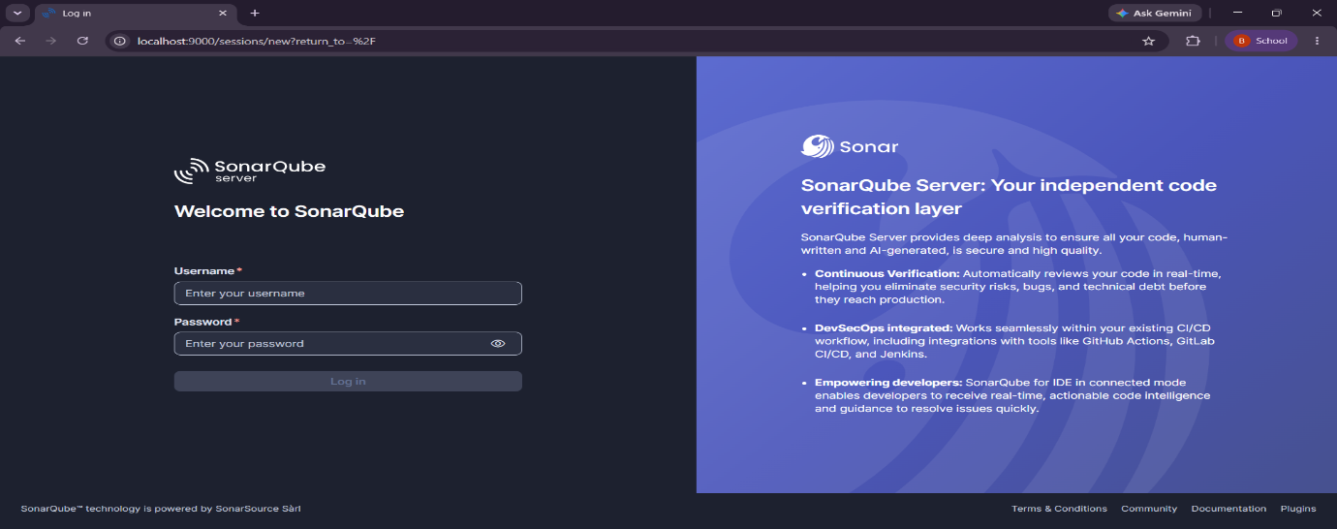
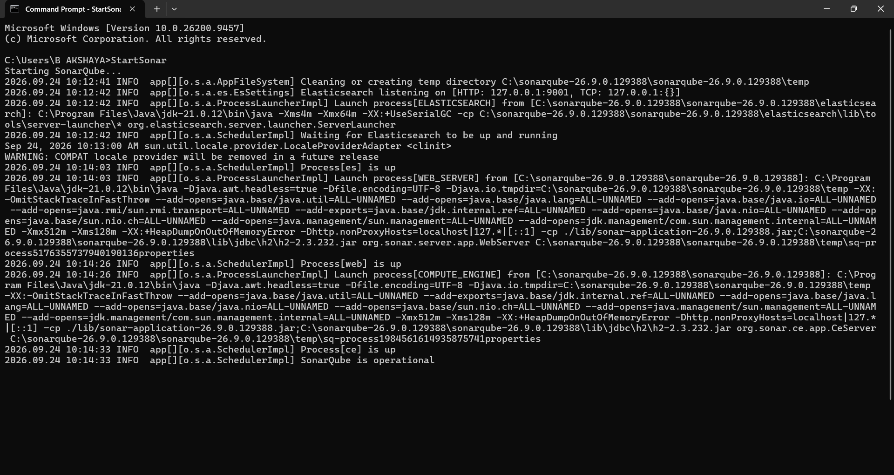
Step2:open browser localhost:9000

Step3:Click on Create a local Project
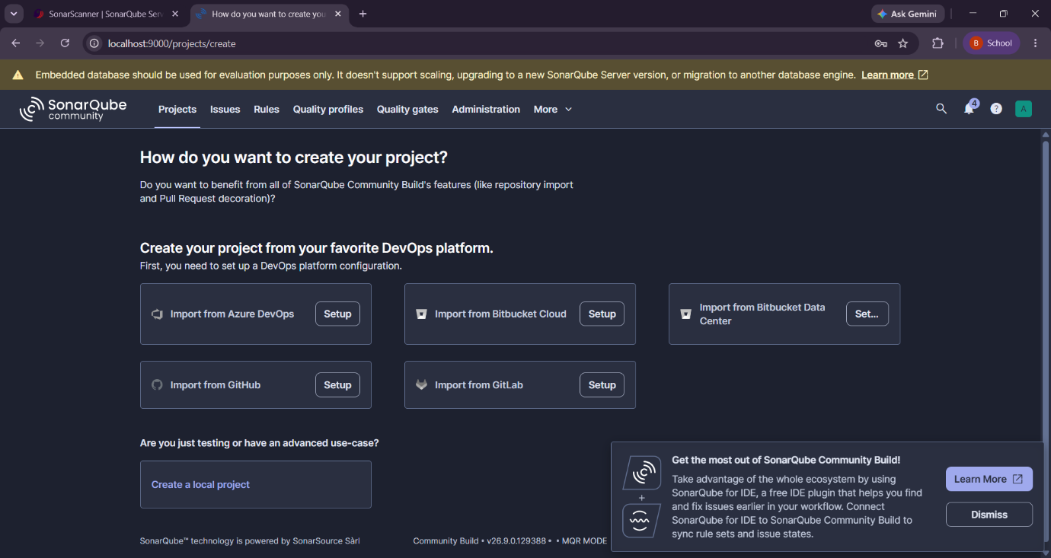

Step4:Enter Project display name, project key, main branch name
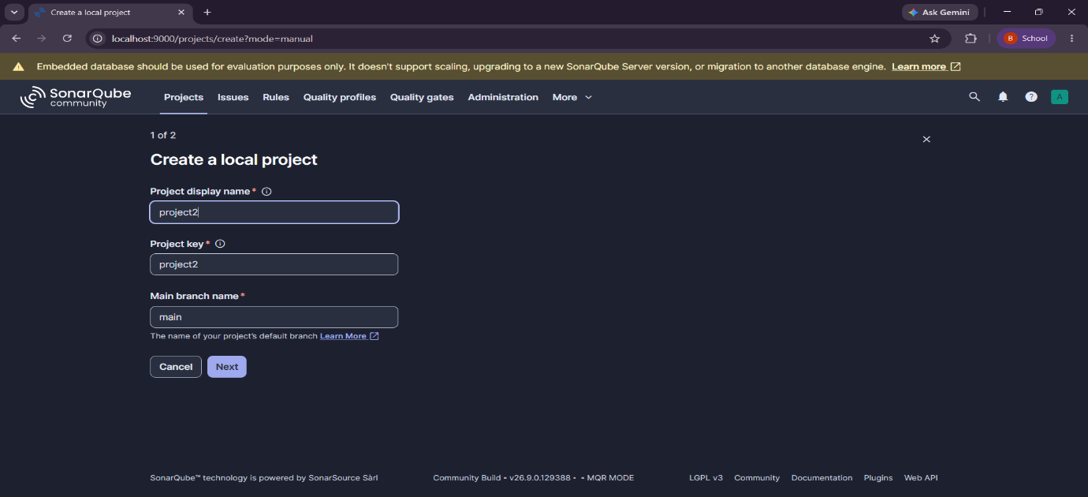

Step5:Select Follows the Instances default and click on create project

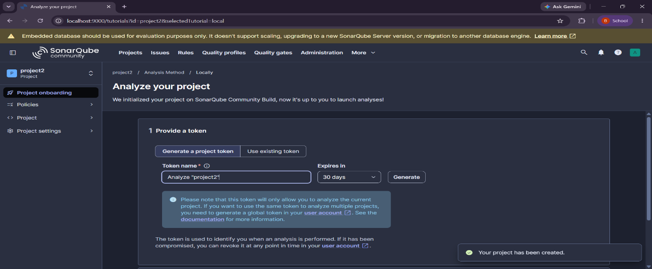
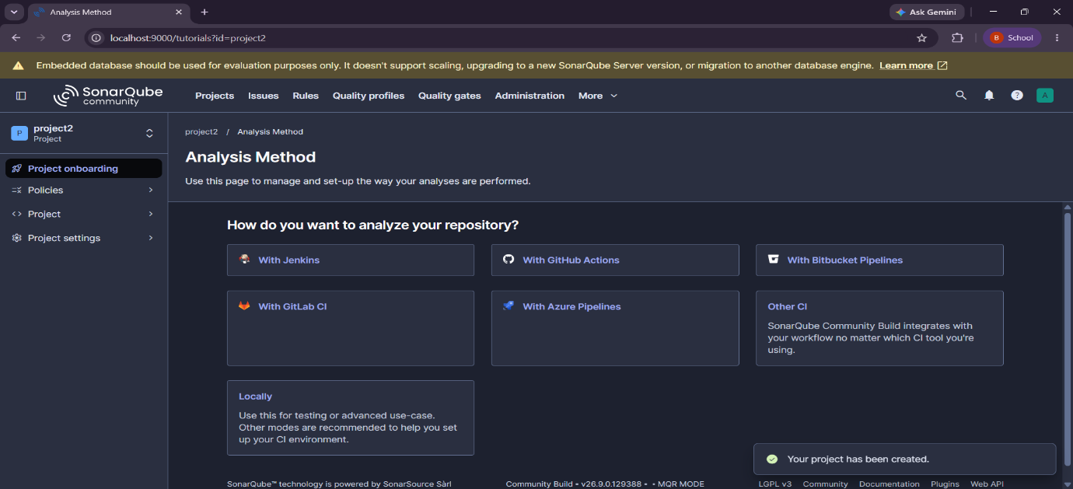
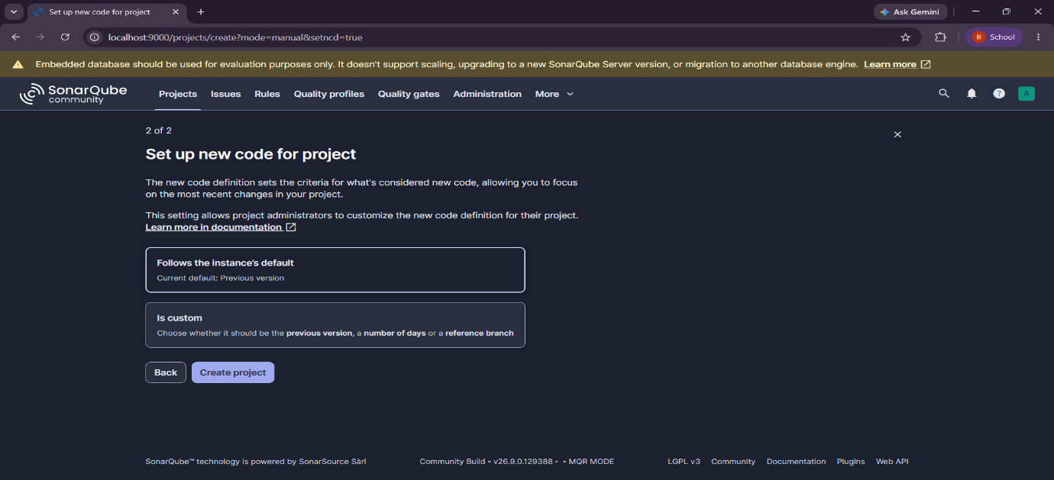
Step6:Click on locally
Step7:Click on generate
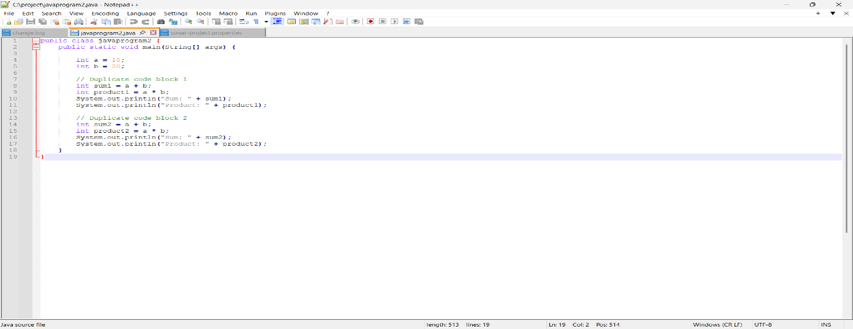
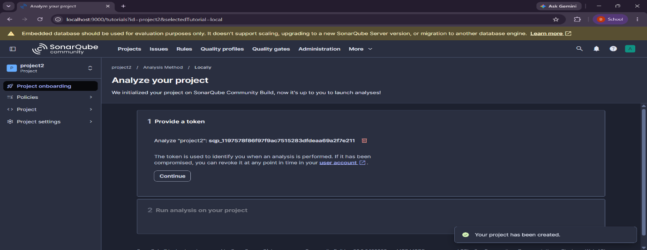
Step8:Click on continue
Step9:Write the code in notepad++ and save it
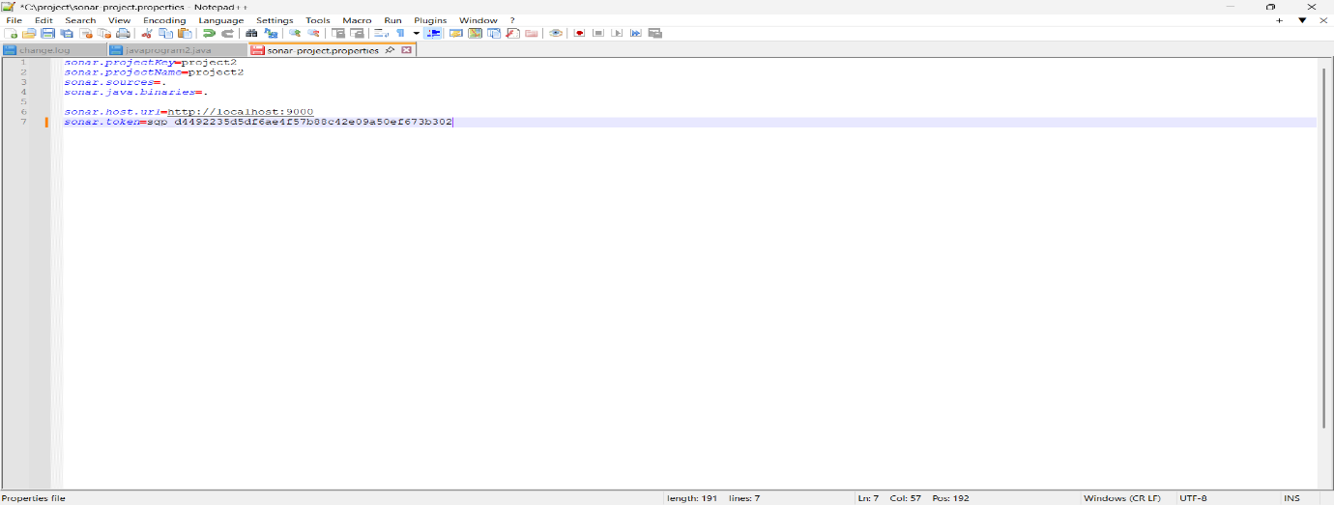
Step10:write the sonar project.properties code and save it
Step11:open new cmd
type sonar -scanner -v and enter
Then,give the path of the folder in cmd
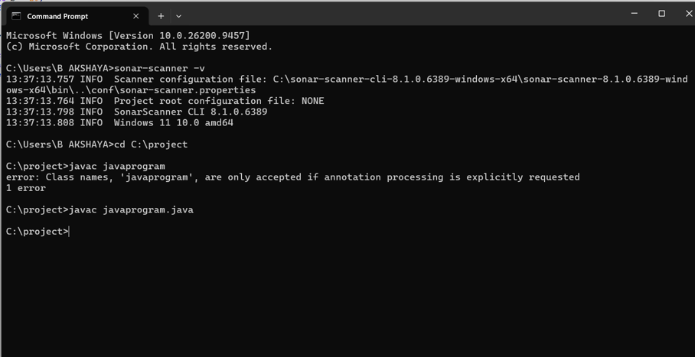
Step12:type javac.javaprogram.java in cmd
Type sonar-scanner
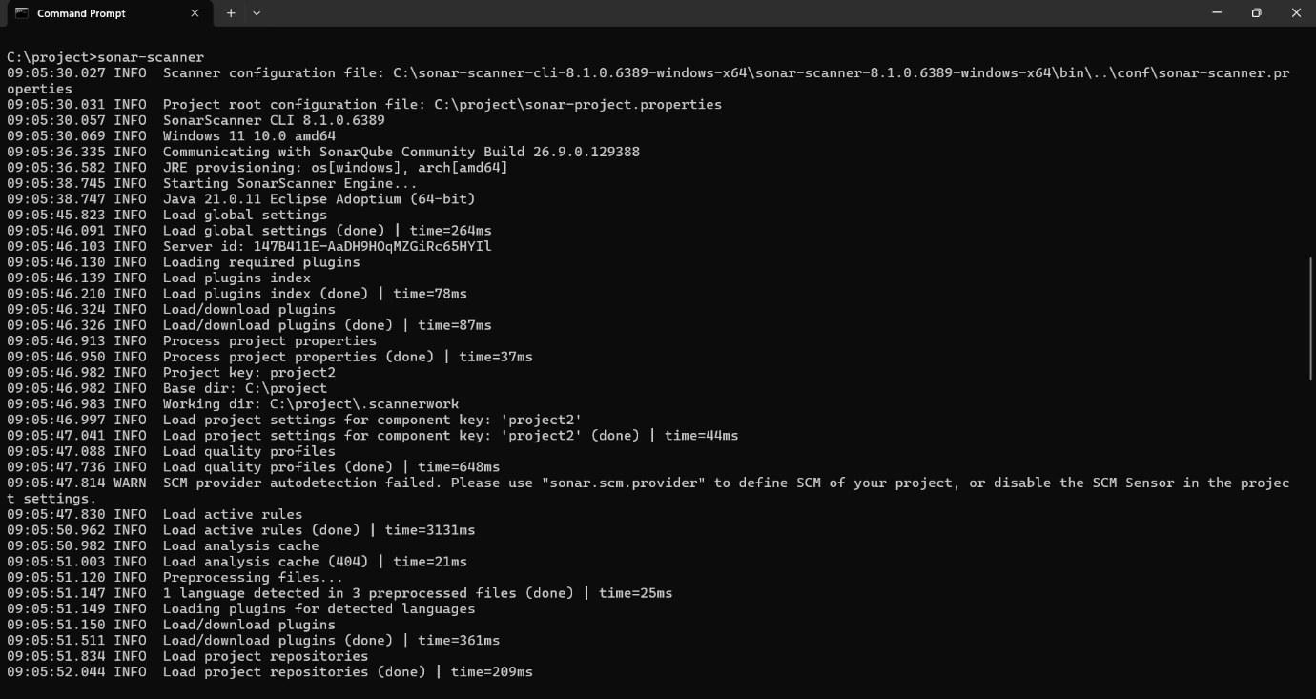
it should show Execution Success

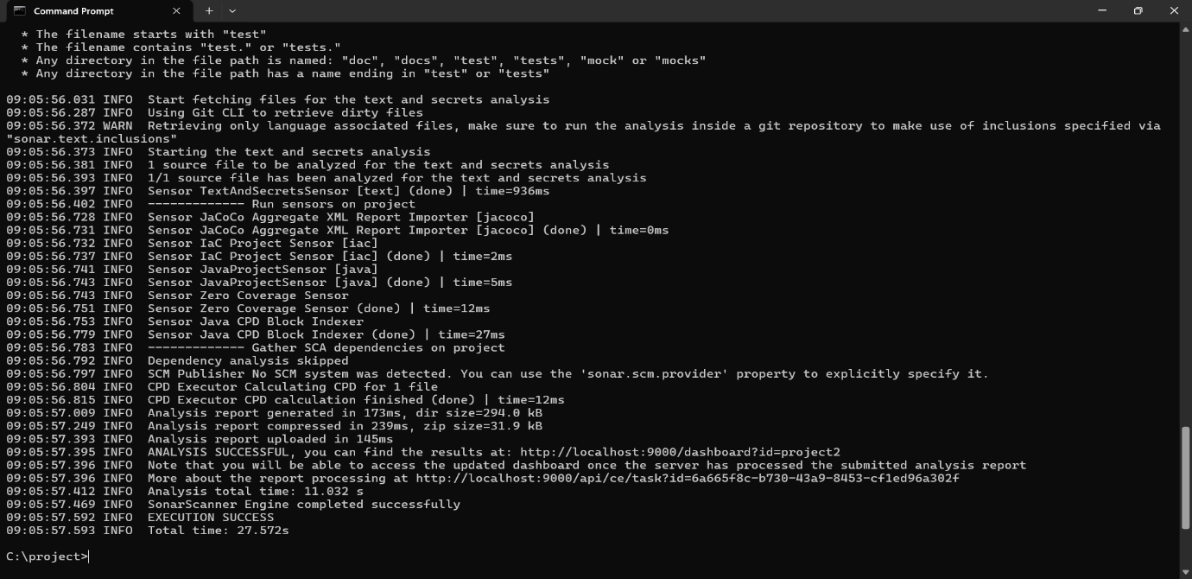
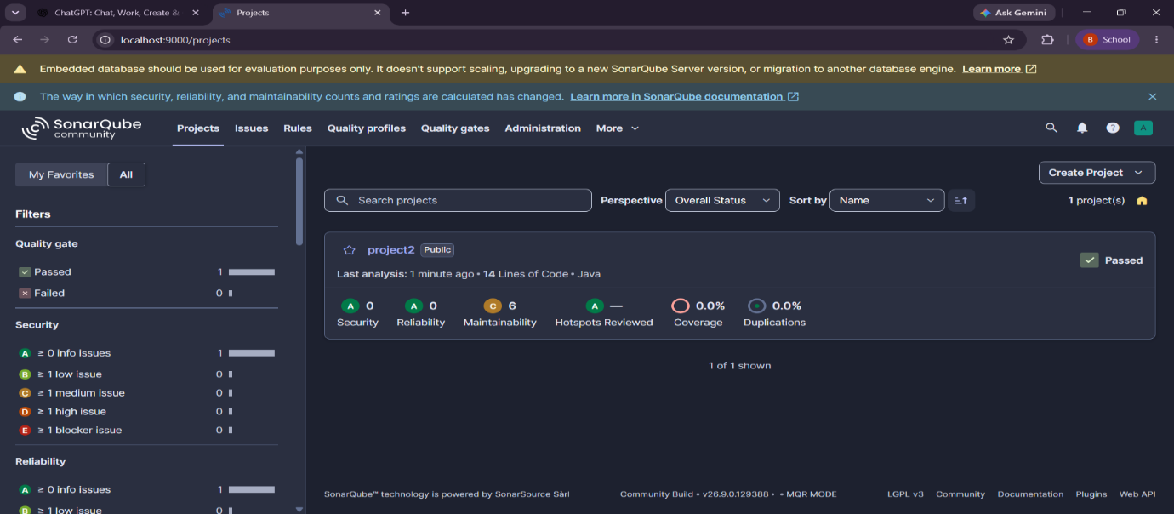
Step13:Open local host and check if project was executed
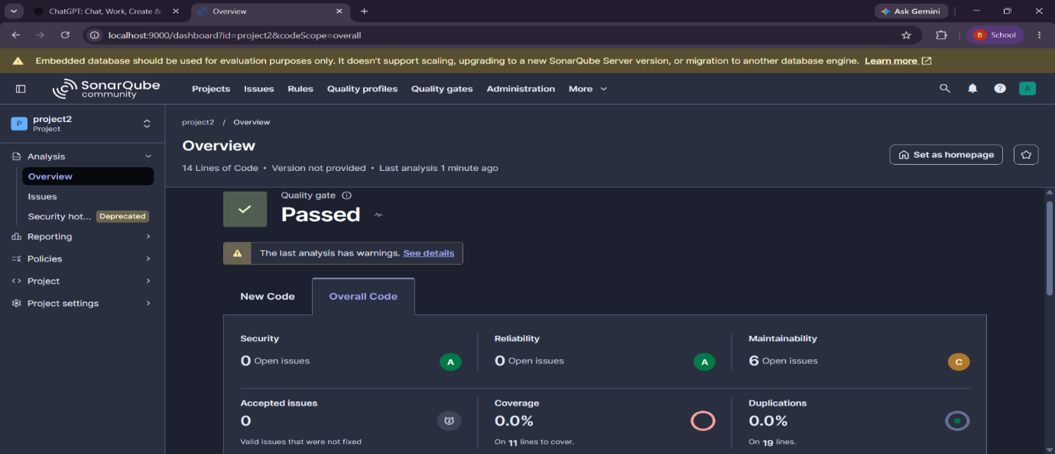
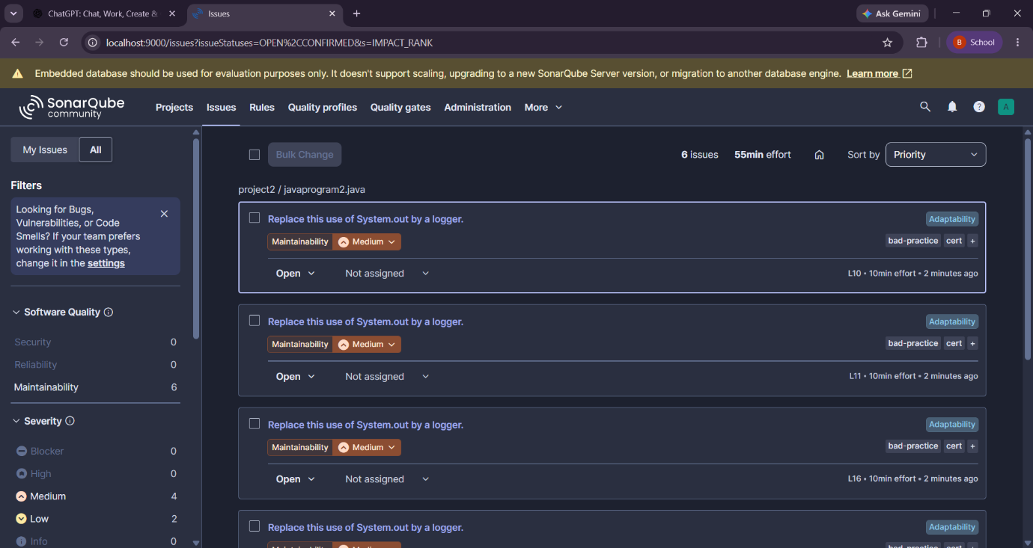
Step14:Then check for issues
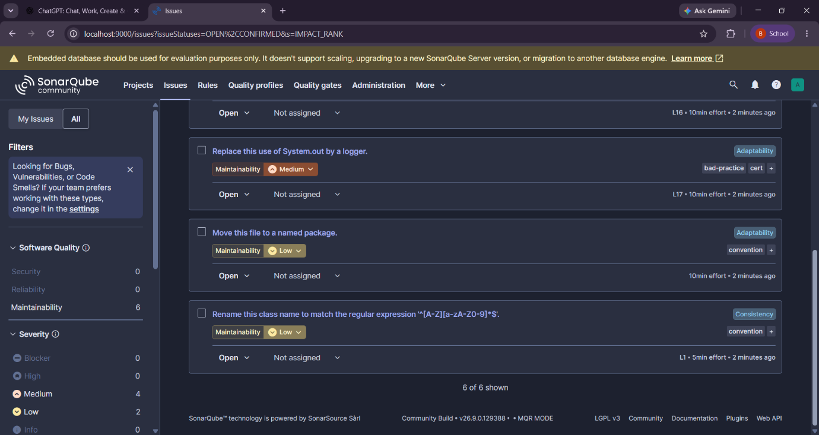

Step15:exit form sonarqube

